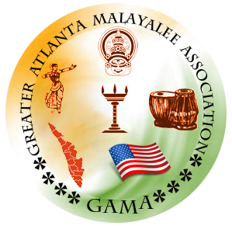

Greater Atlanta Malayalee Association
2022 Annual General Body

2022 Annual General Body was conducted on Dec 03rd at 6:00 PM ET.

Attendees
- General Body started at a packed auditorium around 6:00 PM ET
Meeting Minutes:
- We started the General body meeting with 30 secs silent prayer.
- Followed by US National Anthem and Indian National Anthem
- Welcome Speech by Mrs: Srija Kulakizha
- Presidential Address by Mr. Shajeev Padmanivas
- Financial report by Mr. John Mathai
- Secretary report by Mr. Binu Kasim
- Reports were Proposed by Nithin Ramesh and Seconded by Rekha Jayamon
- General Body Agenda and Resolutions: Following resolutions were approved by General Body
  - All transition Milestones to be reviewed and approved by BOT
  - Financial Accounts to be reviewed and approved by BOT
  - Any Status Changes to GAMA PO. BOX and/or Storage requires approval from both BOT and General Body
  - Any Money withdrawal from CD Account requires approval from both BOT and General Body
  - All Ever-Rolling Trophies requires to be collected in the same Executive Year
  - GAMA Building initiatives like Fund Raising, Building Fund Committee etc will be undertaken between BOT and 2023 Executive Committee.
- 2022 BOT Chairman Mr. Kannan Udayarajan gave the BOT Presidential address.
- BOT chairman introduced the candidates for GAMA 2023 Executive committee.
- Vote Of Thanks was Mr. John Mathai

2022 General body elected the following candidates as 2023 executive committee members.
- Binu Kasim
- Sridevi Ranjit
- Usha Prasad
- Ajith Chandran
- Jayamon Nedumpurath
- John Mathai
- Nafas Sait
- Divya Amarayil
- Subi Thomas
- Noora Ansar
- Aneesh Nair
- Shabeer Jabar
- Sinu Paul

