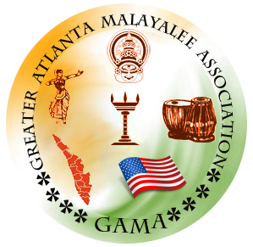

Greater Atlanta Malayalee Association
2021 Annual General Body

2021 Annual General Body was conducted in Zoom platform on Dec 11th, 2021, at 6.30 pm.

Attendees
- Abdul Salam
- Anil Naduvathuparambil
- Anil Nair
- Biju Thomas Thuruthumalil
- Bobby Nehru
- Deepak Alexander
- Aravind Ramachandran
- Thomas K Eapen
- Jaymon Nedumpurath
- John Mathai
- Kannan Udayarajan
- Manoj Thomas
- Navin Job
- Prakash Joseph
- Riyas Sainudheen
- Sandeep Vyasan
- Shaji John Pulliattel
- Tom Joseph
- Kailash Kurup
- Tony Thomas
- Harish Velayudhan
- Nelson Parappully
- Aboobacker Ziddhique
- Shajeev Padmanivas
- Manoj Varghese

Meeting Minutes:
- We started the General body meeting with 30 secs silent prayer.
- Presidential Address by Mr. Thomas Eapen
- Secretary report by Mr. Deepak Alexander
- Financial report by Mr. Thomas Eapen
- Financial report was proposed by Mr. John Mathai and Seconded by Mr. Prakash Joseph.
- Q&A session – GAMA 2021 Executive committee answered the questions asked by the GAMA members.
- 2021 BOT Chairman Mr. Prakash Joseph gave the BOT Presidential address.
- BOT chairman introduced the candidates for GAMA 2022 Executive committee.

2021 General body elected the following candidates as 2022 executive committee members.
- Shajeev Padmanivas
- Binu Kasim
- John Mathai
- Tony Thomas
- Jayamon Nedumpurath
- Anil Nair
- Geethu VenuGopal
- Supriya Namboodiri
- Sreeja Kulakizha
- Manoj Varghese
- Nelson Parappully
- Shaji Kamalasanan
- Harish Velayudhan

